1. Dopplergram data is taken from;

GONG (Global Oscillation Network Group)

MDI (Michelson Doppler Imager) on the Solar and Heliospheric Observatory (SOHO, 1995) - 15 runs of varying length

HMI (Helioseismic and Magnetic Imager) on the Solar Dynamics Observatory (SDO 2010) - 45 runs of 72 days each. = 24 3 day sets

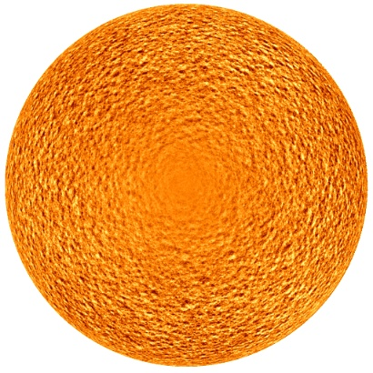

Dopplergrams look like ---->

We obtain solar oscillations from these dopplergrams. We look for a superposition of spherical harmonic functions from l=0 (entire sun expanding and contracting) to l=1000 (very small scale oscillation)

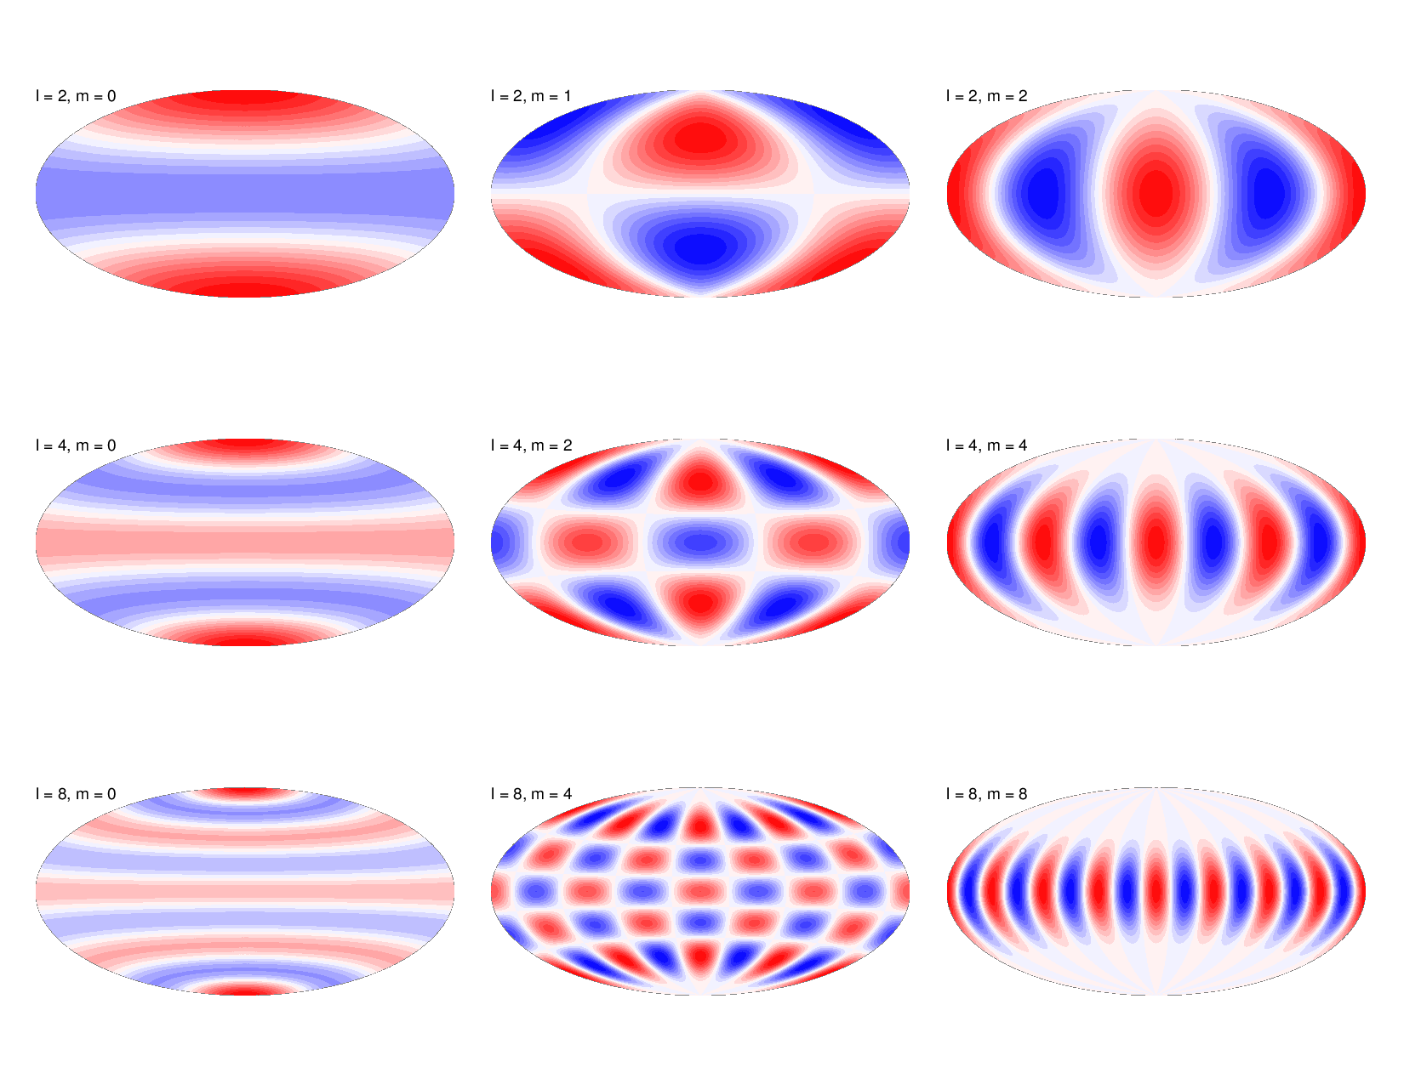m refers to the orientation of the oscillation (we average this out in m-averaging.)

1. Fitting

For each of 3 day set, we plot a l - nu diagram (relates frequency of the oscillation to the spherical harmonic l value from 1-100.) The most dominant solar oscillation happens once every 5 minutes as demonstrated by this 3-d plot with the higher amplitude oscillations shown in ridges. The data shows that more intense oscillations happen on the ridges. 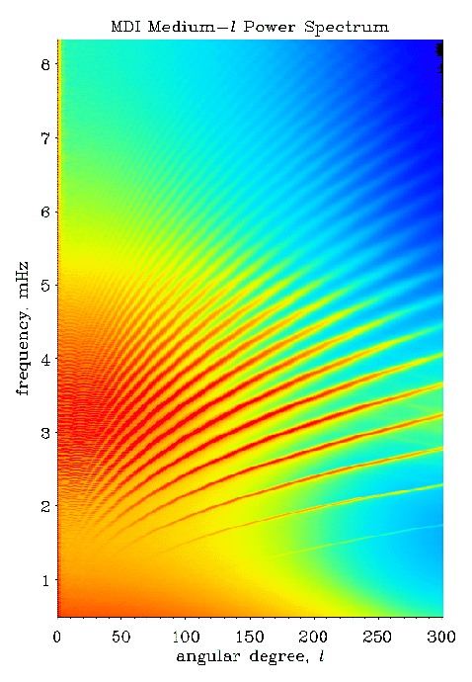

Our fitting function fits theoretical equation parameters to the Dopplergram data and finds various frequencies at different l values.

For amplitudes and line widths: Look at the 3d plot, imagine a z-axis out of the page where we can calculate amplitudes and line widths of the ridges apparent in the data. We use line widths and amplitudes in data analysis too, just not this year in the poster (shown in fig2b&c.)

In the end we end up with a l-nu diagram of 12,228 fitted frequencies for each 3 day set of data. For example, fig2a (24 l-nu diagrams for each HMI run)

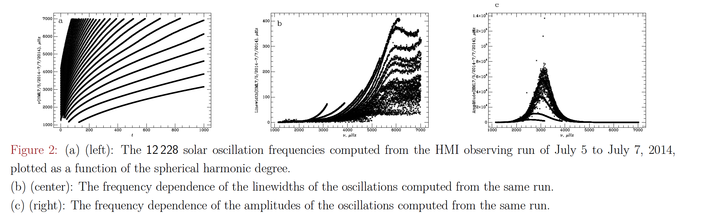

3. Subtraction and binning

For each 72 day HMI run, we have 24 l-nu diagrams. We calculate the differences in frequencies and solar indices (solar activity) by subtracting earlier runs from later runs so the change in time is always positive. (2-1, 3-2, 3-1, 4-3, 4-2, 4-1, 5-4, [...] 24-2, 24-1) End up with a total of 276 differences (23+22+21+[...]2+1)=276

We then get a plot that looks like fig3a for each difference between two 3 day sets (276 plots each with 12,228 differences).

Next is the binning step where we split the frequency range into 25 equally spaced frequency bins (~250 microhertz per bin) and average all differences in each bin to get a nicer looking plot that looks like fig3b. (276 plots each now with 25 averaged differences)

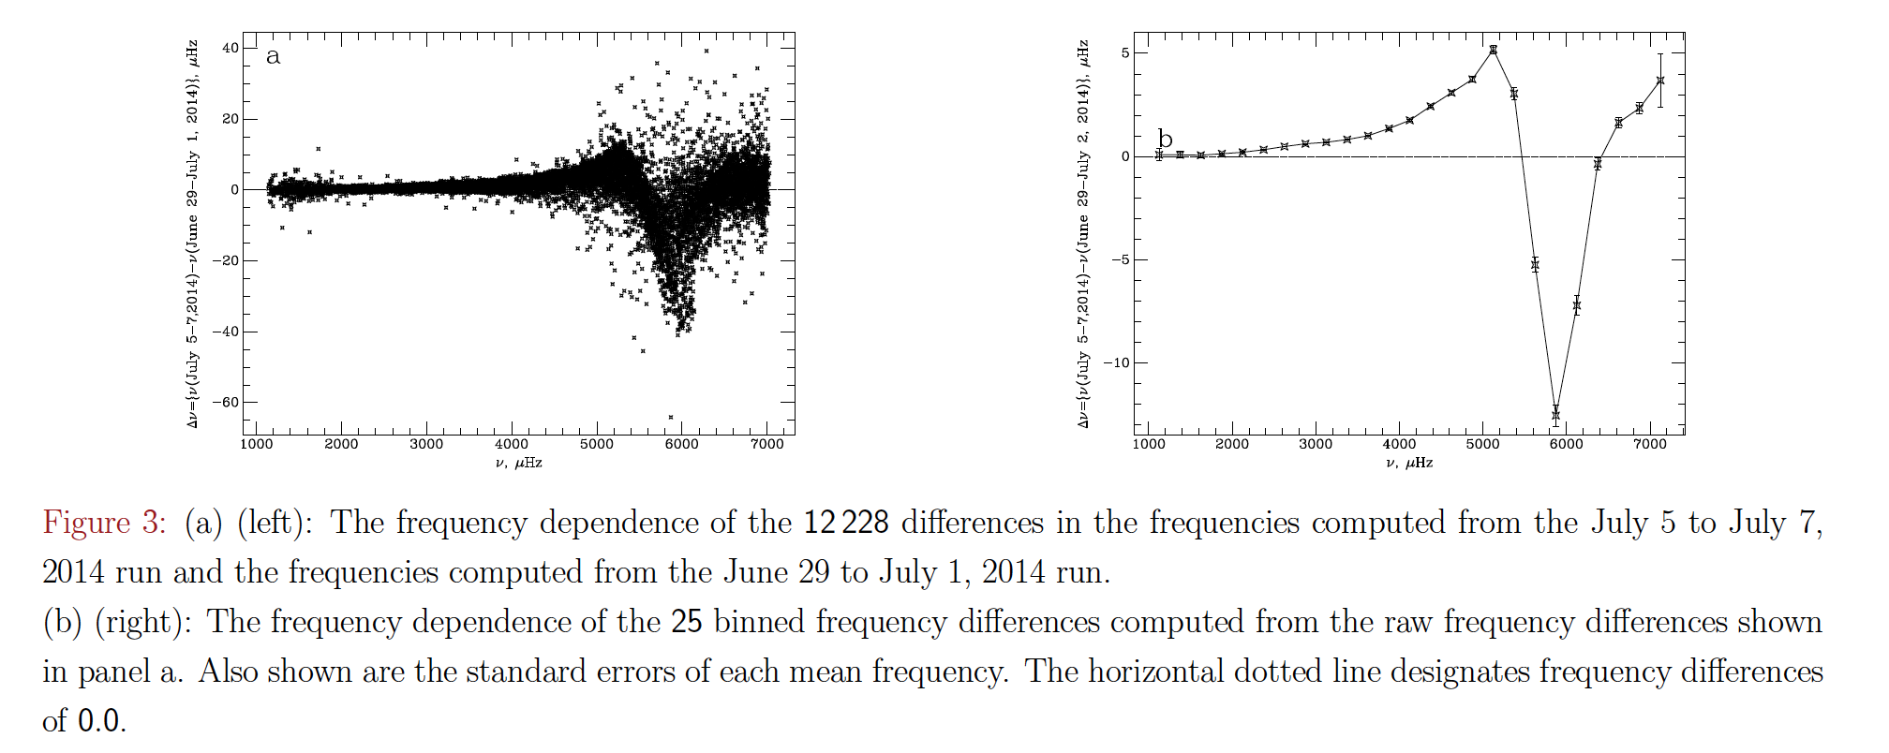

Notice in fig3b the behavior after nu=5000 microhertz. There are few theoretical models that predict or attempt to explain this seismic behavior of the sun. This is why our work is important.

4. Regression

Now we examine the frequency changes vs. changes in a solar activity index.

Take the values of the change in frequency from one bin in each of the 276 binned frequency difference vs. frequency plots from the previous step. Then compare those frequency changes to changes in a solar index. For example, take all 276 frequency change values from the bin centered at nu=4375 and plot them against the differences in MgII core to wing ratio to get fig4a. Notice the high level of correlation possibly showing that seismic activity in the sun is correlated to the solar activity indices. This correlation is represented by the correlation coefficient (r-value). Fig5a shows a positive correlation and fig5b shows a negative correlation but both are statistically very significant (low change of being correlated by random.)

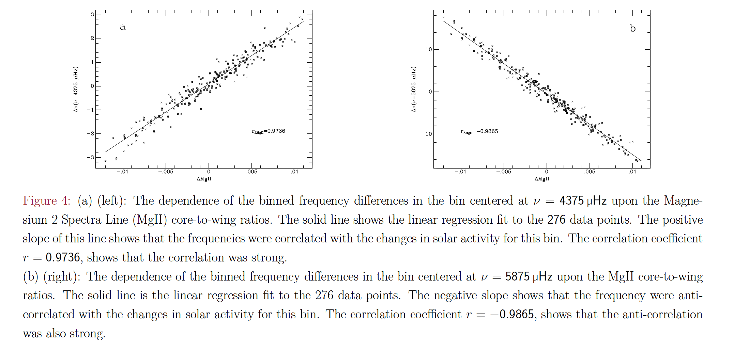

By performing this regression step on all 25 bins in a run, we obtain 25 graphs with correlation coefficients which we can then plot against the frequency of the corresponding bins.

Note: The Mg II core‐to‐wing ratio is a measure of the amplitude of the chromospheric Mg II ion emission at 280 nm. Mg II both absorbs and emits. It is an indicator of solar activity.

5. Finding the zero-crossing frequencies

Next we investigate how the correlation coefficients change based on the frequency of the bin the regression analysis was performed on.

Take the 25 correlation coefficients from each run and plot them versus the frequency of their corresponding bins. This results in a plot like fig5a for one run. Notice that the correlation coefficients cross from being positive to being negative at around 5500 microhertz and then cross from being negative to being positive at around 6500 microhertz. This crossing frequency we will now refer to as the +/- and -/+ zero-crossing frequencies and can point to some not yet discovered seismic property of the solar atmosphere. We obtain one +/- and one -/+ zero crossing frequency from each run so in total we have 15 of each zero-crossing frequency from MDI and 45 of each zero-crossing frequency from HMI.

We have repeated all above steps for all 45 HMI runs and 15 MDI runs so we can look at the time dependence of the zero-crossing frequencies. This is shown in fig5b for Solar Cycles 23 and 24 (15 MDI runs and 45 HMI runs, each run is one data point on each line).

Our next and last step is to investigate how the zero-crossing frequencies relate to our solar activity index (MgII Core-to-Wing Ratio over time shown in fig5c)

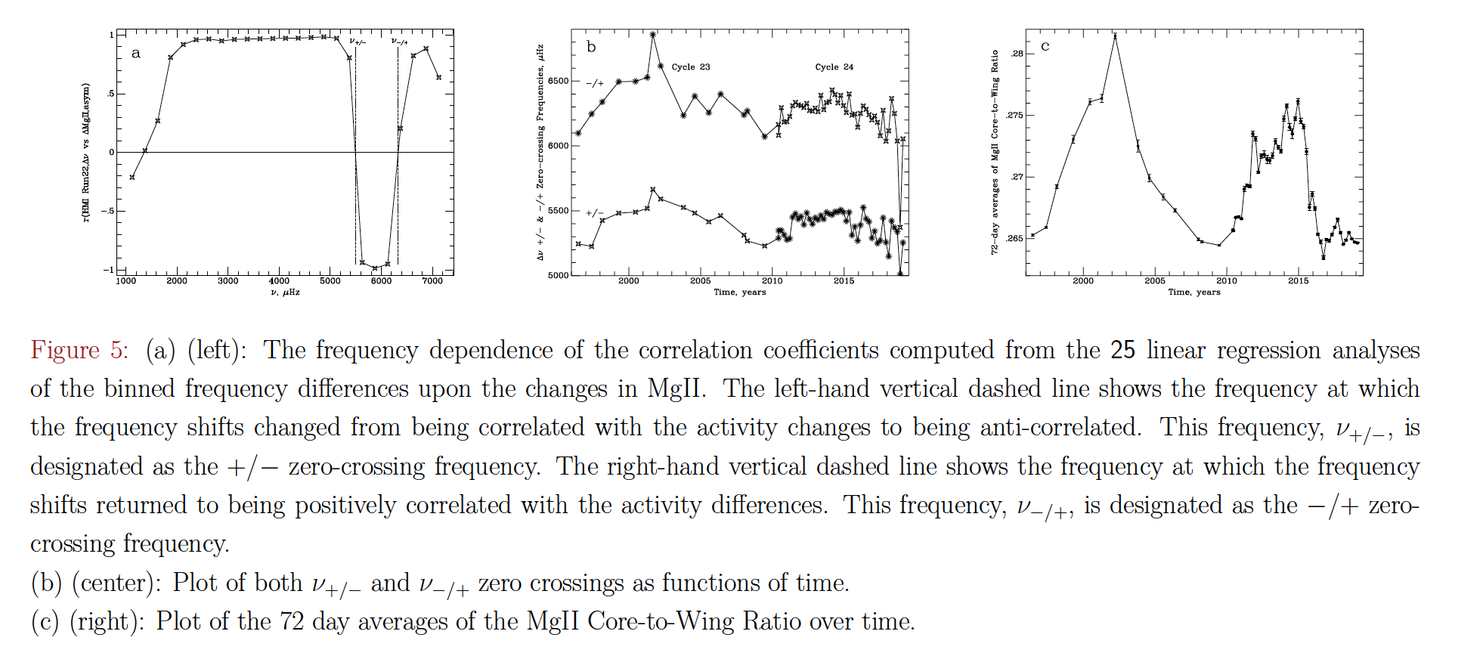

6. Long term analysis of the relationship between zero-crossing frequency and solar activity.

What we have done until now is considered short term analysis (on the scale of one run or 72 days) we are now doing long term analysis to try to see differences in the seismic properties of the sun between Solar Cycles 23 and 24. We first plot +/- zero-crossing frequencies vs. MgII Core-to-Wing Ratio for both Solar Cycles 23 and 24. We then do the same plotting for -/+ zero crossing frequencies. These are shown in fig6.

Notice that the slope of the fitted lines differ between Solar Cycles 23 and 24 by about 40% at a statistically significant level (90% or more). This is our result! Showing that it appears there are differences in the relation between seismic activity and solar activity indices between Solar Cycles 23 and 24.

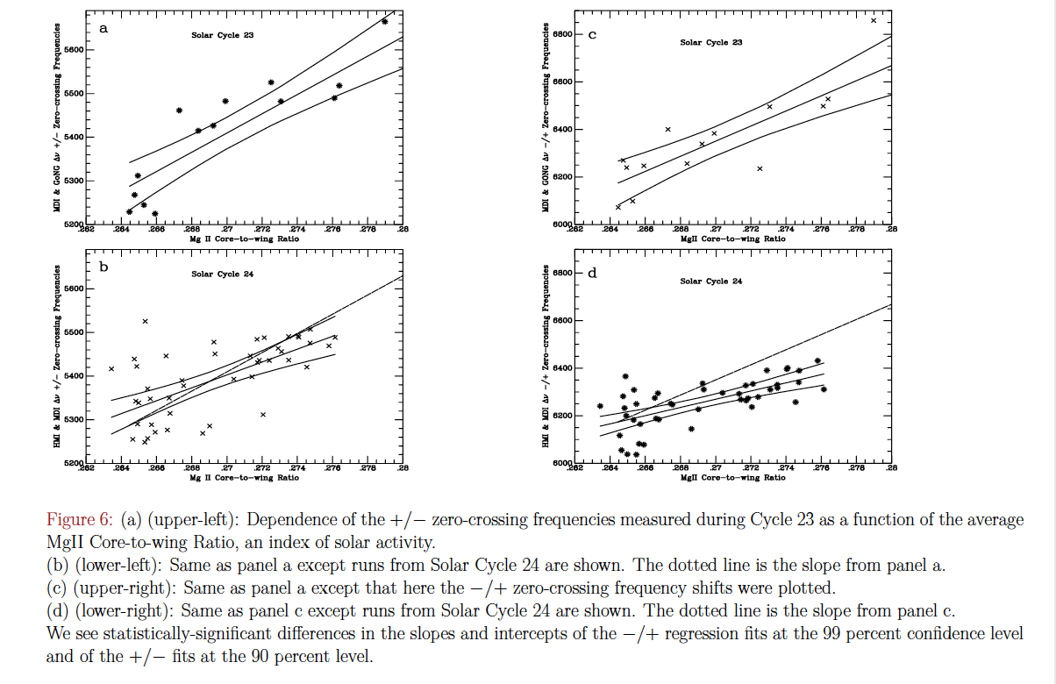

We hope this result spurs further analysis and theories on the seismic structure of the solar atmosphere.